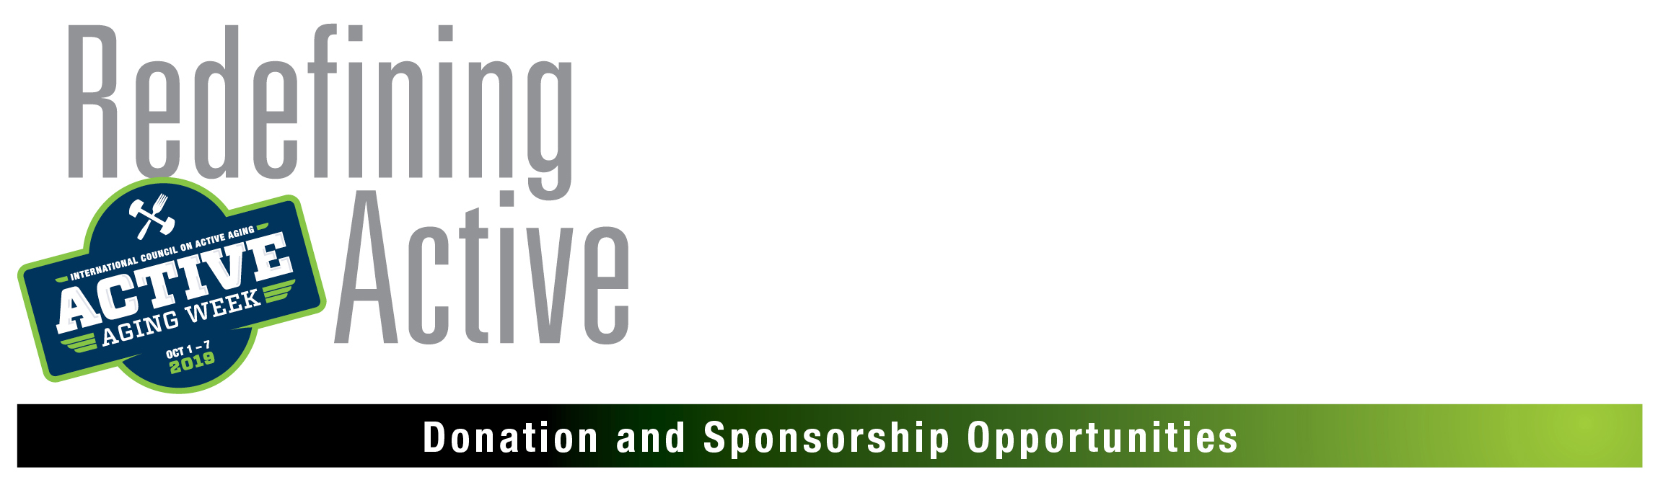

Local contact:

[Your name, organization, phone and e-mail]

Goal: | Active Aging Week promotes the benefits of a healthy lifestyle on a national scale by giving older adults the opportunity to experience activities and exercise in a safe, friendly and fun atmosphere.
When: | Tuesday, October 1 through Monday, October 7, 2019
Where: | [fill in your location(s)]
What: | [place your activities here, with dates]
Who will attend: | - [estimated number of participants]  - [target audiences]
Opportunities: | [list what you will offer sponsors, eg, logo on marketing materials, or coupon placed in gift bag going to each participant, or signage on event]
Event organizer: | Active Aging Week is organized by International Council on Active Aging (ICAA) the association that supports professionals who develop wellness and fitness environments and services for adults over 50.
Active aging: | Active aging promotes the vision of all individuals—regardless of age,  socioeconomic status or health—fully engaging in life within seven dimensions of wellness: emotional, environmental, intellectual/ cognitive, physical, professional/vocational, social and spiritual.
Websites: | [your organization name and web site here]  Active Aging Week www.activeagingweek.com

